3A/3B HUMAN BIOLOGICAL SCIENCE
APPLECROSS SENIOR HIGH SCHOOL

DO NOT WRITE ON TEST PAPER

Choose the best alternative and answer on multiple choice answer sheet.

- The nitrogen bases adenine, guanine, thymine and cytosine spell out a chemical code. This code is important because:

(a) it produces nucleotides.
(b) it codes for amino acids.
(c) it codes for ATP.
(d) it is a gene, which gets mutated to produce more advanced forms of life

- The diagram represents a model of DNA replication. The steps are numbered.

Which of the following is the correct order?

- 1,2,3,4
- 2,3,4,1
- 2,4,3,1
- 4,1,4,3

3. Which is true of a codon?
a) It consists of three nucleotides.
b) It may code for the same amino acid as another codon does.
c) It never codes for more than one amino acid.
d) It extends from one end of a tRNA molecule

4. Which does NOT represent a difference between RNA and DNA?
a) RNA is single stranded.
b) RNA contains the sugar ribose.
c) RNA substitutes thymine for uracil.
d) RNA utilizes nucleotides in its structure.

In questions 5 and 6 below, a segment of DNA has one strand with the following sequence of bases.
A G C G C A T A G C A A

5 The complementary strand of DNA is
a) U C G C G U A U C G U U
b) T C G C C G A T C G T T
c) T C G C G T A T C G T T
d) T C G C A T T A C A U U

6 The mRNA molecule coded for by the original strand is
a) T C G C G T A T C G T T
b) U C G C G U A U C G U U
c) U A C A T T U C A G G G
d) U C G G C A T T U G G C

7 In a eukaryotic cell, transcription takes place _____.
a) on free ribosomes
b) in the rough endoplasmic reticulum
c) in the cytoplasm
d) in the nucleus

8 Which are arranged in the correct order by size, from largest to smallest?
a) chromosome - gene - nucleotide - codon
b) chromosome - gene - codon - nucleotide
c) codon - chromosome - gene - nucleotide
d) nucleotide - chromosome - gene - codon

9. Imagine an error occurring during DNA replication in a cell, so that where there is supposed to be a T in one of the genes there is instead a G. What effect will this probably have on the cell?

a) The amino acid sequence of one of its kinds of protein will be completely changed
b) Each of its kinds of protein will contain an incorrect amino acid
c) One of its kinds of protein might contain an incorrect amino acid
d) An amino acid will be missing from one of its kinds of protein

10. During the process of translation, ________ matches an mRNA codon with the proper amino acid.
a) DNA polymerase
b) transfer RNA
c) a ribosome
d) messenger RNA

11. What is transcription?
a) The modification of a strand of RNA prior to the manufacture of a protein.
b) The manufacture of a strand of RNA complementary to a strand of DNA.
c) The manufacture of a protein based on information carried by RNA.
d) The manufacture of two new DNA double helices that are identical to an old DNA double helix.

Use the model below to answer questions 12 and 13.
Translation of the genetic code occurs in the cytoplasm of a cell. The following diagram is one representation of translation.

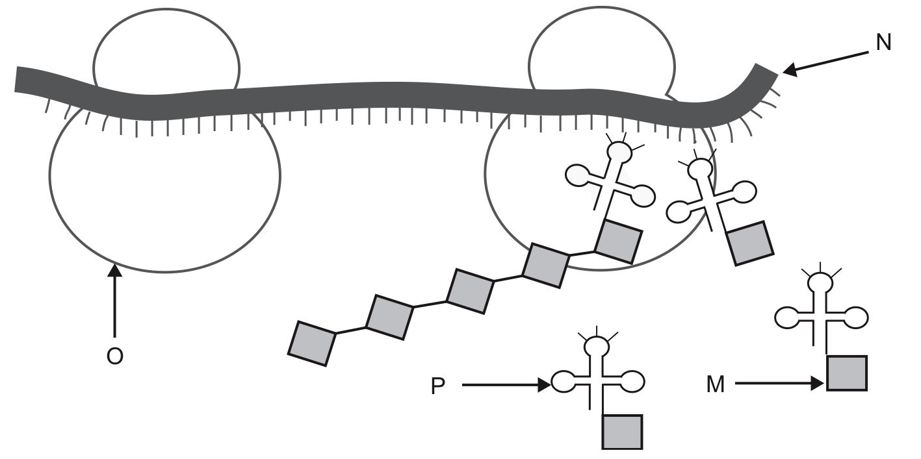
12. In the model presented

a) M represents a ribosome.
b) N represents messenger RNA.
c) O represents transfer RNA.
d) P represents an amino acid.

13. In the model presented

a) N represents a ribosome.
b) P represents messenger RNA.
c) O represents transfer RNA.
d) M represents an amino acid.

14. Nucleotides contain which of the following?
(a) protein, chromosomes, genes.
(b) Nitrogen base, sugar, phosphate.
(c) Protein, carbohydrate, DNA.
(d) Sugar, fat, coiled proteins.

15. Which of the following statements is the best description of a gene?
(a) A gene is the total DNA complement of an individual.
(b) A gene is a sequence of nucleotides that carries the code for a protein.
(c) A gene is a protein molecule which occurs in chromosomes.
(d) A gene is the smallest unit of structure in a chromosome.

16. Nucleotides contain which of the following?
(a) protein, chromosomes, genes.
(b) Nitrogen base, sugar, phosphate.
(c) Protein, carbohydrate, DNA.
(d) Sugar, fat, coiled proteins.

17. Which one of the following processes does NOT take place in the nucleus?
a) replication of DNA
b) translation
c) removal of introns from RNA
d) transcription

18. Which of the following is a description of chromatin?

a) All the genetic sequences contained by members of a particular species.
b) The protein coding sequences and their regulatory elements.
c) Repetitive sequences contained within the genome of an organism.
d) The DNA – protein complex which comprises eukaryotic chromosomes

19. A particular ____ carry the information for making a particular polypeptide, but ____ can be used to make any polypeptide
a) gene and ribosome ... tRNA and mRNA
b) gene and mRNA ... a ribosome and tRNA
c) ribosome and mRNA ... a gene and tRNA
d) gene and tRNA ... a ribosome and mRNA

20. The diagram shows portion of a cell engaged in protein synthesis. The various parts of the cell are not drawn to scale.
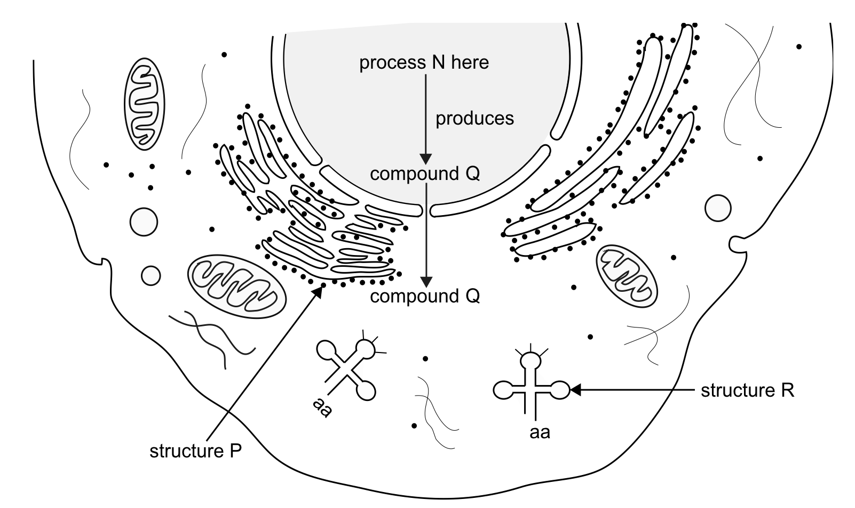

It is reasonable to conclude that
a) process N is translation.
b) structure P is made of t-RNA.
c) compound Q is messenger RNA.
d) structure R is the site of protein synthesis.

WRITTEN SECTION: WRITE YOUR ANSWERS IN THE SPACES PROVIDED

Name: _______________________________________________ MC /20 Written /10

Total Mark: /30

1. Complete the table below to illustrate the differences between messenger RNA and transfer RNA. (5 marks)
 | mRNA | tRNA
Location in cell

Function

Structure (size or length)

Amino acid present?

Codons or Anti-codons?

2. Number the processes below from 1 to 8 in order of their occurrence in protein synthesis.
Number | Process
 | mRNA attaches to a ribosome
 | A tRNA with an anticodon brings the correct amino acid and attaches to the matching mRNA codon
 | mRNA travels from the nucleus to the cytoplasm
 | mRNA forms with complimentary bases to the template strand of DNA
 | Amino acids are bonded together to form the protein
 | The mRNA undergoes modification – the introns are removed, leaving the exons
 | The two strands of the DNA in a gene separate
 | At the start codon, the ribosome begins reading the mRNA code

Which of the above numbers correspond to the process of translation?
___________________________________________________

(5 marks)

